EXTRAQC QUALITY CONTROL SOFTWARE.

By Enric Aguilar¹ and Marc Prohom²

1: Center for Climate Change, C3, Universitat Rovira i Virgili de Tarragona, Spain
2: Climate Change Team, Climate Area, Servei Metorològic de Catalunya, Barcelona.

Introduction.

The EXTRAQC routines are a set of R-coded functions for quality control. Although they can be used in a stand-alone version, which allows more flexibility, they have been integrated by the authors into the widely used ETCCDI software RClimDex, to produce an unofficial version called RClimDex-Extraqc.
These functions are prepared based upon the long experience accumulated by the authors in quality controlling temperature and precipitation data with RClimDex and other software and in training third users to do so. EXTRAQC routines focus mainly on temperature data and include the following tests:

– Duplicate dates control
– Rounding problems evaluation
– Out of range values, based on fixed threshold values
– Outliers, based on Interquartile Range exceedance
– Interdiurnal differences based on fixed threshold values
– Coherence between maximum and minimum temperatures (Tmax > Tmin)
– Consecutive equal values control

EXTRAQC produces numerical and graphical output, automatically stored in your computer, following RClimDex conventions. The next section describes how to run EXTRAQC and the expected output.

Running EXTRAQC

Once in R, after loading the source file rclimdex_extraqc.r, press the second button, labeled Run extra QC.

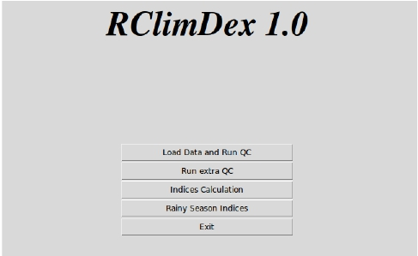

After doing so, the software will present a pop-up window to navigate through your disk and select the file you are intending to quality control.

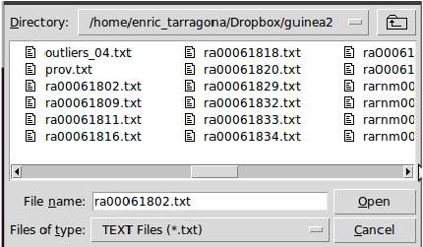

After completing your selection, a message will appear indicating that you are running the extra qc functions (press OK). After the quality control is finished, a pop-up window will warn you. Loading and running EXTRAQC needs the same data format as other RClimDex functionality and is subjected to the same potential format errors, which can be solved identically to those with RClimDex.

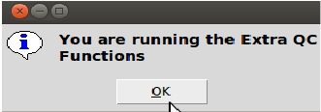

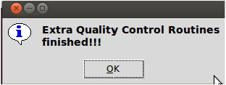

Once EXTRAQC has finished for the first time, your working directory will present a new folder named extraqc, where the numerical results and plots for the different tests will be stored.

Your extraqc folder will contain the following files:

– 3 pdf files, with graphical information on data quality:
– mystation_boxes.pdf
– mystation_boxseries.pdf
– mystation_rounding.pdf

– 8 text files with numerical information on data quality
– mystation_duplicates.txt
– mystation_outliers.txt
– mystation_tmaxmin.txt
– mystation_tx_flatline.txt
– mystation_tn_flatline.txt
– mystation_toolarge.txt
– mystation_tx_jumps.txt
– mystation_tn_jumps.txt

These files offer useful information to flag data quality control problems.

QUALITY CONTROL FILES CONTENTS:

mystations_boxes.pdf:

This software uses the interquartilic (IQR) to identify potential outliers. The IQR is defined as the difference between the 75th (p75) and the 25th (p25) percentiles. As can be seen in the example below, the mystation_boxes.pdf file contains boxplots of temperature and precipitation data flagging as outliers (round circles) all those temperature values falling outside a range defined by p25 – 3 interquartilic ranges (lower bound) and p75 + 3 interquartilic ranges (upper bound) . For precipitation, 5 IQR are used.

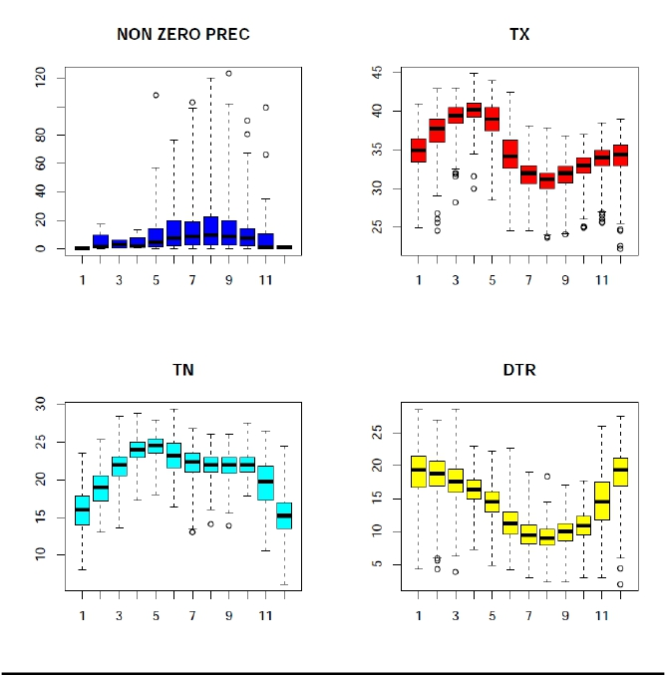

The values identified by this graphical quality control, are sent to a simple text file, the mystation_outliers.txt. The file lists the outliers grouped under the element that produced the inclusion of the record in the file and specifying the margin (upper bound or lower bound) that is surpassed. So, under pc up appear those values that represent a precipitation outlier; under tx up those that represent a maximum temperature higher than p75+3*IQR; under tx low outliers that represent an observation lower than p25-3*IQR. The explanation given for tx, also applies to tn and dtr. The advantage of this approach is that the detection of this percentile based outliers is not affected by the presence of larger outliers, so ONE RUN OF THE PROCESS IS ENOUGH!
Each record listed includes: year, month, day, precip, tx, tn and dtr. NA stands for not available.

pc up
1987 5 9 108.1 32.5 NA NA
1993 7 24 102.7 32.1 22.1 10
2003 9 21 123.2 33 20.2 12.8
1976 10 24 80.2 26.1 19.6 6.5
1980 10 10 90.1 33 21.5 11.5
1976 11 1 66.2 32.8 20.5 12.3
2000 11 11 99.3 32.5 21.4 11.1
tx up
tx low
1980 2 5 2.1 25.5 21.2 4.3
1980 2 6 0.9 24.5 18.6 5.9
1980 2 7 0.1 26.8 18.5 8.3
1992 2 13 0 26 20 6
1977 3 27 0 31.8 25.5 6.3
1981 3 21 5.9 28.2 24.4 3.8
1981 3 22 0.4 31.6 20.9 10.7
1982 3 11 0 32 19.7 12.3
1976 4 18 0 31.6 24.3 7.3
1987 4 5 0 30 NA NA
1985 8 5 1.6 23.8 NA NA
1985 8 25 1.6 23.6 NA NA
2006 9 23 0.9 24 19 5
tn up
tn low
1989 7 16 7.5 31.5 13 18.5
1989 7 21 62 31 13 18
1979 8 6 3.6 32.5 14.1 18.4
1985 9 12 0 31 13.9 17.1
tr up
1979 8 6 3.6 32.5 14.1 18.4
tr low
1980 2 5 2.1 25.5 21.2 4.3
1980 2 6 0.9 24.5 18.6 5.9
2005 2 14 0 29 23.4 5.6
1981 3 21 5.9 28.2 24.4 3.8
1976 12 19 0 22.2 17.8 4.4
1995 12 15 2.2 22.5 20.5 2

The graphic file boxseries.pdf (which does not have a numerical counterpart) produces annual boxplots. This file is useful to have a panoramic view of the series and be alerted of parts of the series which can be problematic (see values around 1984 in the example)

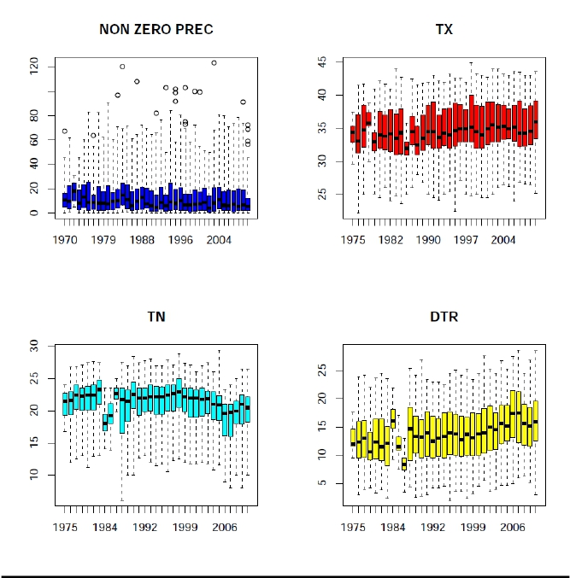

The third graphical quality controls the file mystation_rounding.pdf. It looks at rounding problems by plotting the values after the decimal point. It shows how frequently each of the 10 possible values (.0 to.9) appears. It is expected that .0 and .5 will be more frequent (although there is no statistical reason for this!), but if the rest of the values are not represented, one might think of discarding the series or using a statistical approach to restitute the 1/10th of degree resolution.

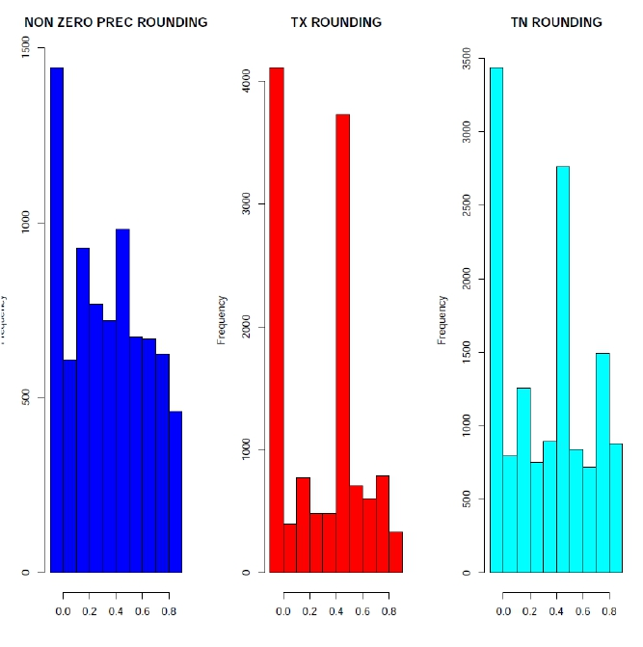

The mystation_tn_flatline.txt and mystation_tx_flatline.txt report on occurrences of 4 or more equal consecutive values in, respectively, tmax and tmin. The text file outputs a line for each sequence of 4 or more consecutive equal values, with 5 fields: year, month, day, value and length of sequence. In the example below all sequences are 4 values long. The date specified belongs to the end of the sequence.

1988 12 24 13 4
1989 8 10 23.5 4
1989 8 29 23 4
2009 9 9 21 4

Looking at the data, the first sequence identified by the QC test is shown below.

1988 12 21 0.00 33.0 13.0
1988 12 22 0.00 32.5 13.0
1988 12 23 0.00 31.0 13.0
1988 12 24 0.00 32.0 13.0

The file mystation_duplicates.txt includes all dates which appear more than once in a datafile. Each record contains 3 fields: year, month, day and refers to the duplicated date. In the listing below, one can see that days between 1958/08/21 and 1951/09/02 are duplicated.

1951 8 21
1951 8 22
1951 8 23
1951 8 24
1951 8 25
1951 8 26
1951 8 27
1951 8 28
1951 8 29
1951 8 30
1951 8 31
1951 9 1
1951 9 2

The file mystation_toolarge.txt reports precipitation values exceeding 200 mm (this and any other threshold can be easily reconfigured before execution) and temperature values exceeding 50 ºC. Fields included are year, month, day, precip, tmax, tmin. In the example below, a temperature of 99.9 does not pass this QC test.

1951 8 23 0 99.9 21.7

The files mystation_tx_jumps.txt and mystation_tn_jumps.txt will list those records where the
temperature difference with the previous day is greater or equal than 20 ºC. The outputted fields are year, month, day and difference with the following day. In the example below, the 99.9 temperature detected by the previous QC, appears here twice, as produces two excessive interdiurnal differences.

1951 8 22 69.4
1951 8 23 72.3

Finally, the mystation_tmaxmin.txt file, includes all those cases where maximum temperature is lower than minimum temperature. Fields included are year, month, day, precip. tmax, tmin.

1951 8 27 0.7 21.1 29.1
1951 8 28 27.8 18.7 27.5

